KING JAMES I ACADEMY
PE BULLETIN
Ms J Humble December 2021

Rock Climbing

A group of Year 10 and 11 GCSE PE students were taken to Rof 59 at Newton Aycliffe to complete part of their practical assessment in rock climbing. Students participated in a range of activities including belaying, traversing and pinching. Students worked exceptionally well and some even completed the overhang. This has ensured top practical grades for a number of students.

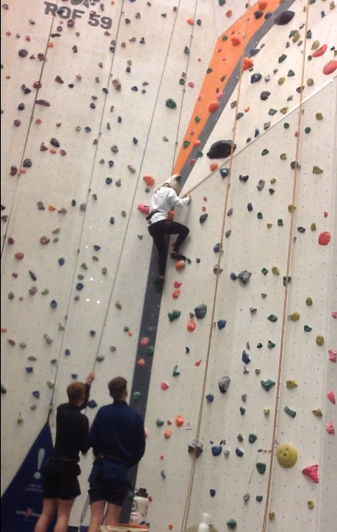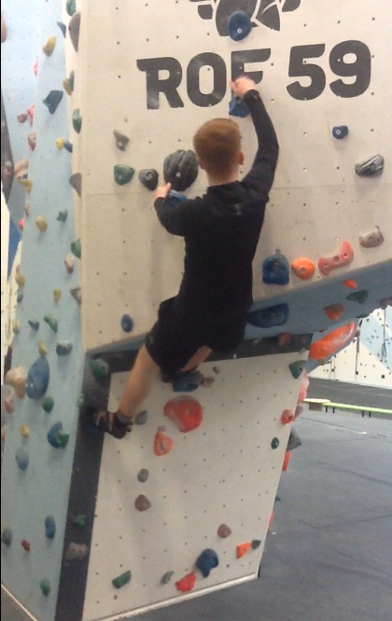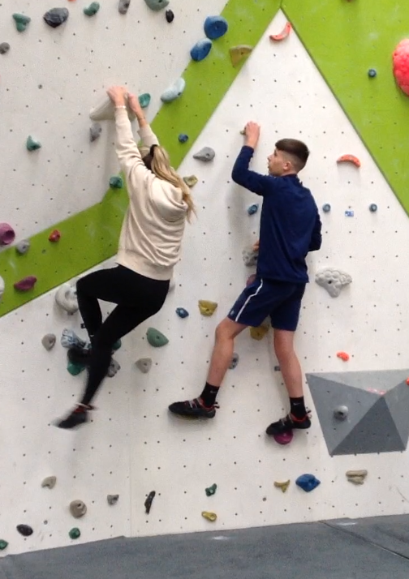

5 a side football

Year 7 boys and girls took part in a 5 a side football tournament at Sedgefield this term. They played a number of fixtures against various other schools including Woodham, Teesdale and Barrington. Unfortunately, they didn’t make the finals but there were some good individual performances from Aiden Nicholson who was top goal scorer for the boys and Alisha Garrett who defended well throughout.

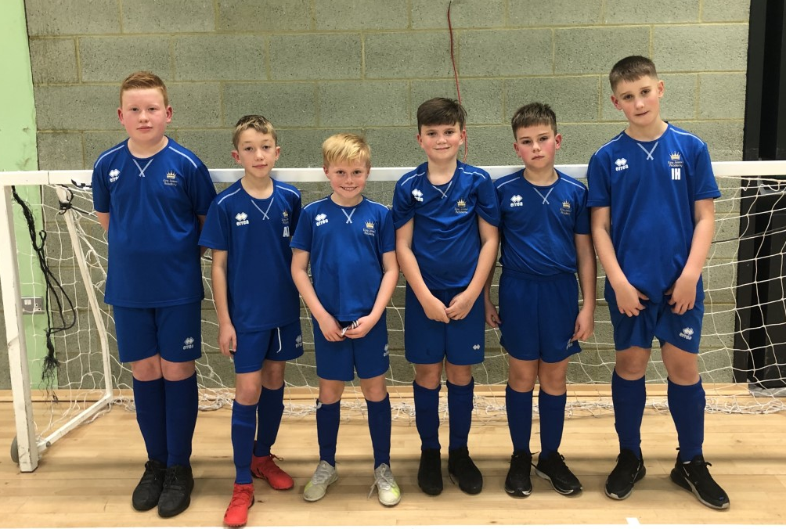
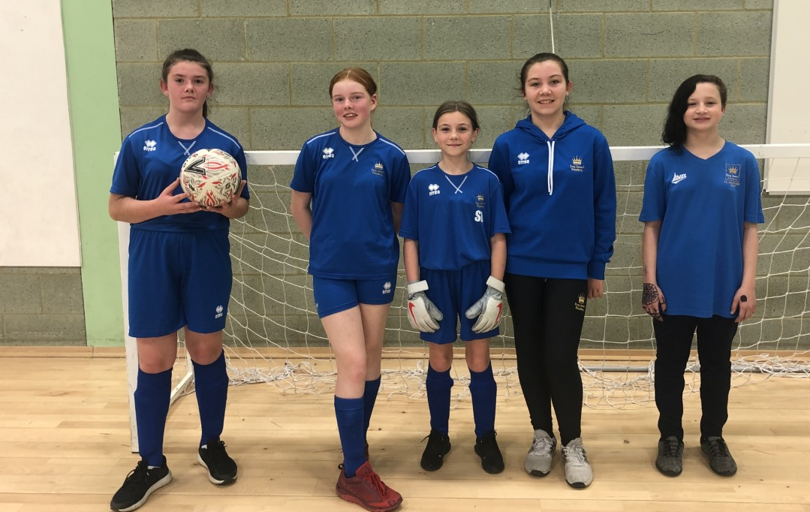

Student of the Term

Each PE teacher nominated a student for autumn student of the term. These students were awarded with a certificate and a £5 voucher. Congratulations to these students.

Year 7 Girls = Emily Smith
Year 7 Boys = Byron Collingwood
Year 8 Girls = Autumn Grace Kelly
Year 8 Boys = Charlie Broom
Year 9 Girls = Tyler Bell
Year 9 Boys = Brooklyn Lamb
Year 10 Girls = Amelia Dickinson
Year 10 Boys = Alfie Canavan
Year 11 Girls = Tilly Robinson
Year 11 Boys = Will Wiseman

Boxing
Ethan Alison in year 11 has reached the national Championship Semi-finals after winning the Tyne Tees and Wear Junior Development Championships. Well Done Ethan! A fantastic achievement.

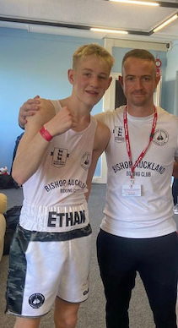

KS3 Curriculum (January-April)

GIRLS – Dance, Tag Rugby, Trampolining, Badminton, Fitness, Volleyball and Cricket.
BOYS – Fitness, Trampolining, Badminton, Basketball and Hockey.

Junior and Inter Cross Country

The Junior and Inter cross country championships took place on Thursday 18th November at Barnard Castle. Teams from years 8/9 and 10/11 represented the Academy. The best result came from Amelia Dickinson who finished 12th and now qualifies for County. Well Done Amelia a fantastic achievement!!

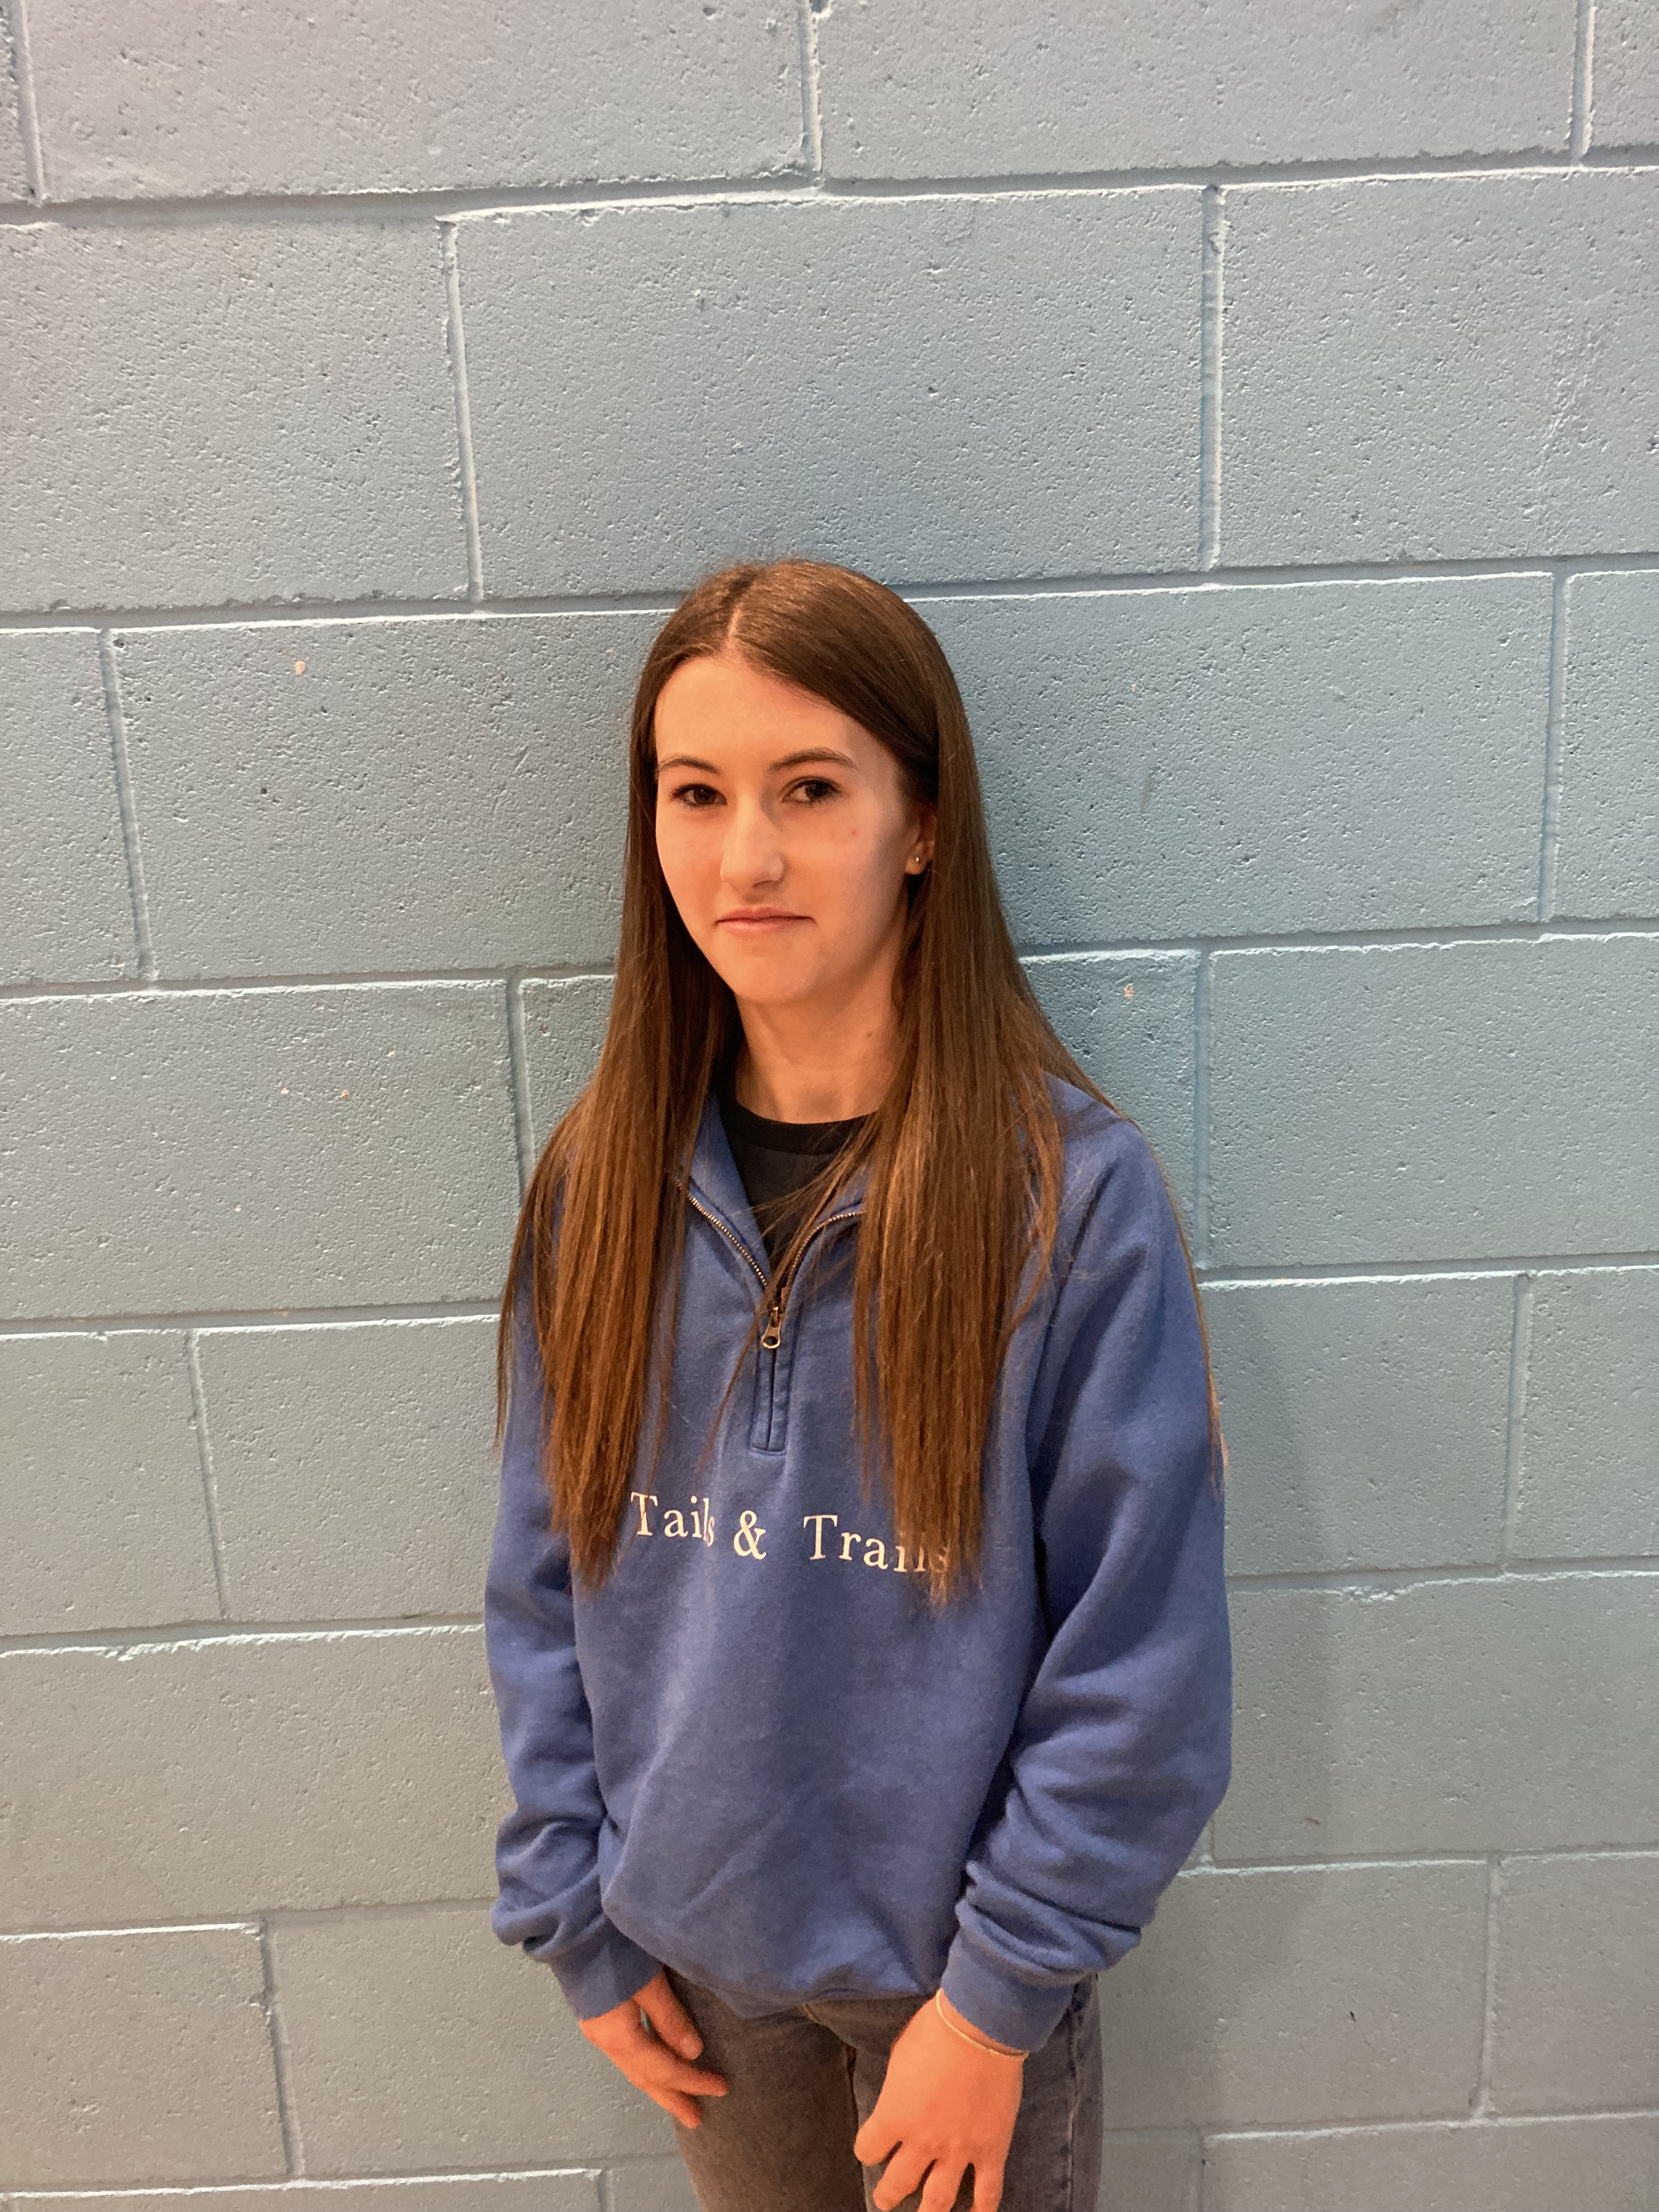

Year 7 / 8 Cross Country Championships

Year 7/8 cross country championships were held at Barnard Castle on Tuesday 16th November. King James had teams for both boys and girls representing the Academy. There was some fantastic effort shown throughout and they represented the Academy well.

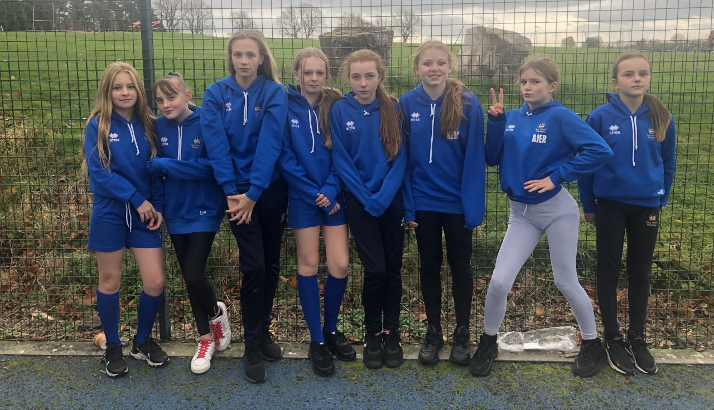

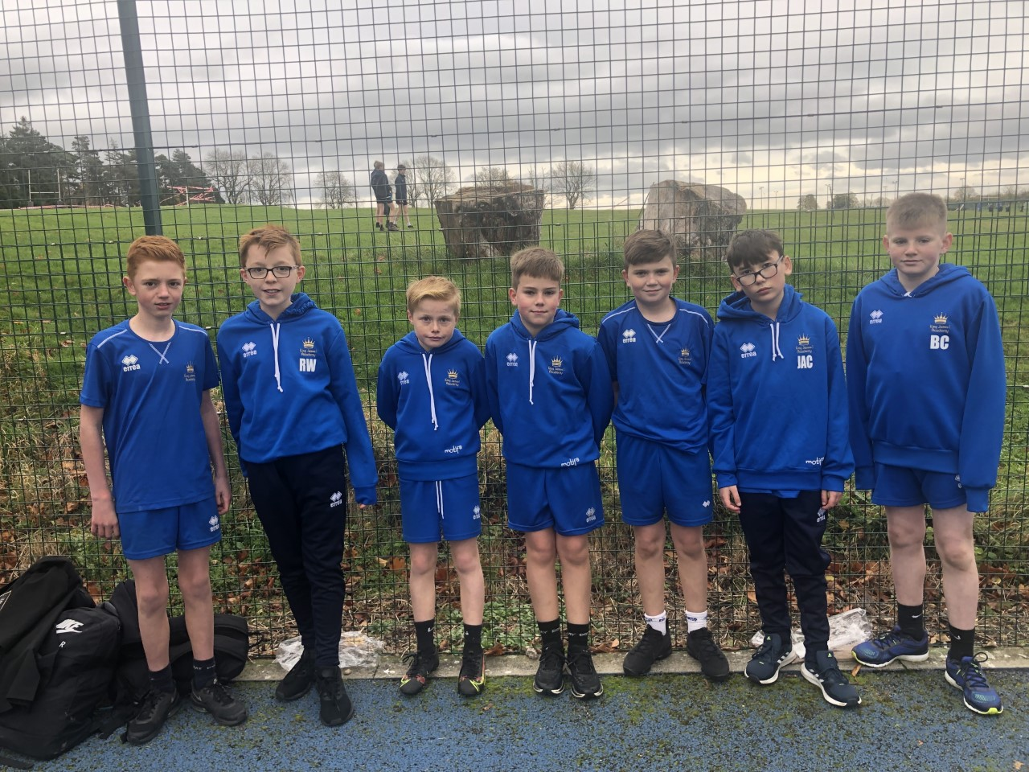

There were some fantastic individual performances the best from Byron Collingwood who finished 10th and now qualifies for county competition in January.

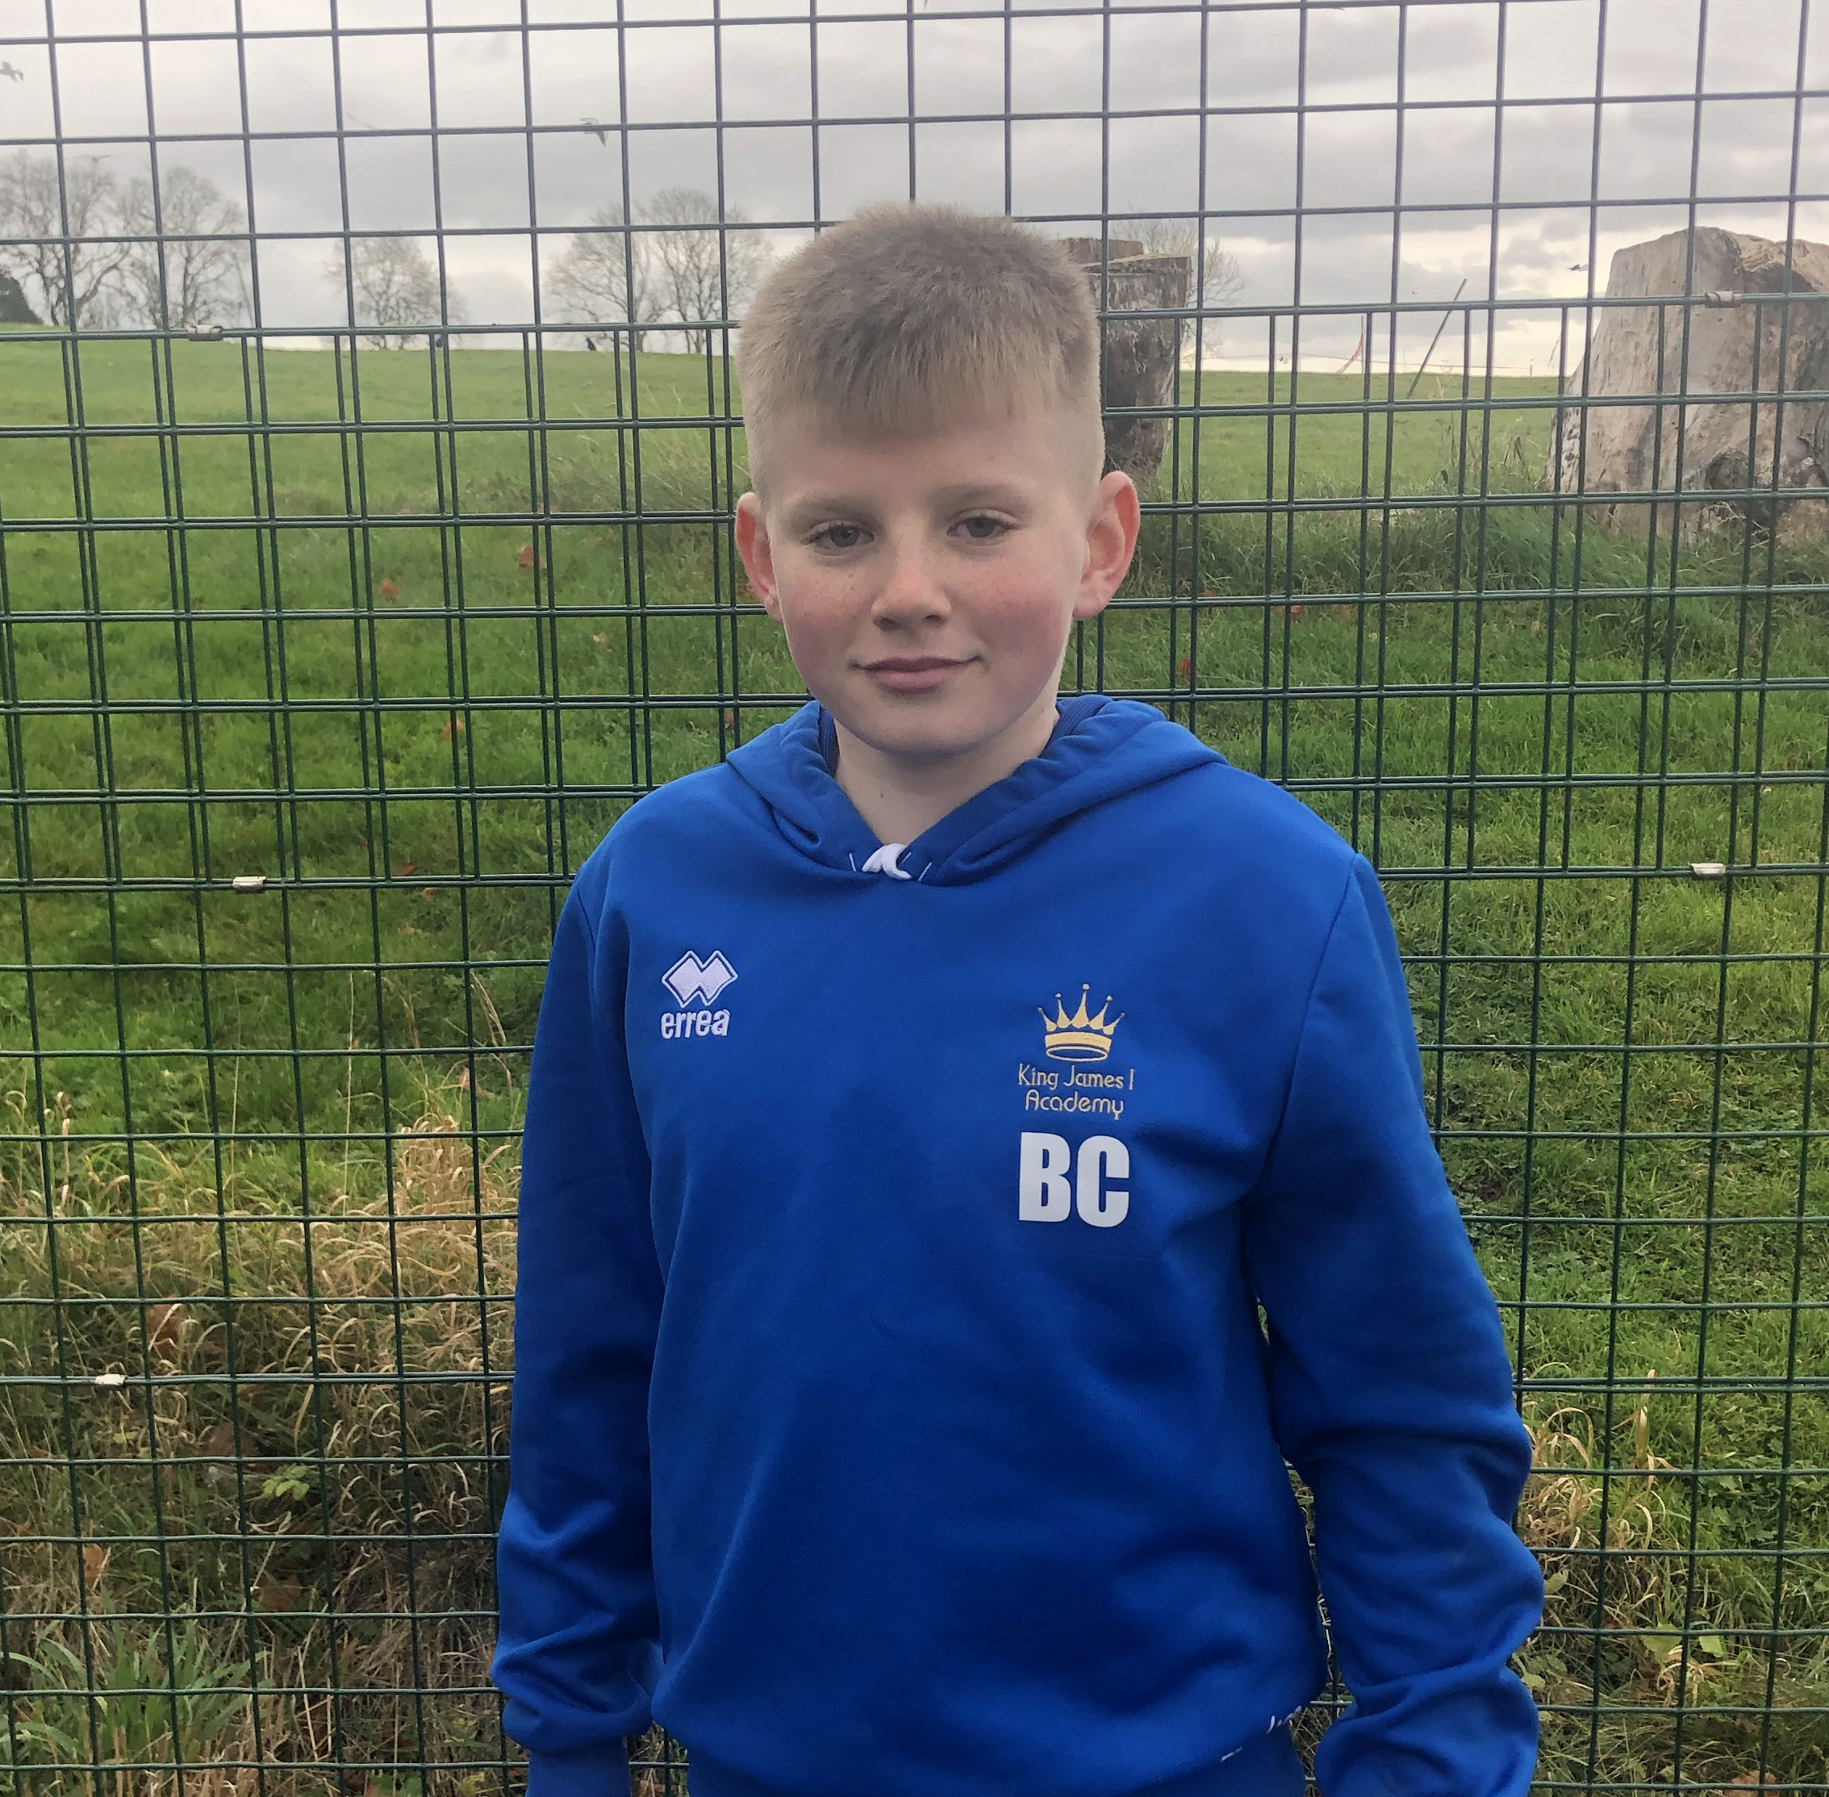

Football

King James I Academy football teams have been playing fixtures since September with some mixed results but great effort shown from all players. Year 7 narrowly lost to Ferryhill 6-5 but year 9 won against Bishop Barrington 7-2, a fantastic result. Fixtures will resume after the Christmas break. We’ve also had a number of students selected to try out for district teams with several being successful. Well done to year 8 students Charlie Broom, Nevan Lamb and Leon Monaghan and year 9 students Bradley Hughes and Jayden Bowes who are now representing district for their year groups. A fantastic achievement! Well Done!!

KJ1A Talent

Our very own Sowerby siblings have been talent spotted by GB!! They’ve been offered the opportunity to represent Great Britain in Thai Boxing. What a fantastic opportunity. Let the fund raising commence.



