KING JAMES I ACADEMY
PE BULLETIN
Ms J Humble December 2023

Football
King James football teams have played a number of fixtures with mixed results.
Year 10 Boys Football Team (2023-2024) Won on Penalties Our Lady and St Bede RC Academy, Lost 7-0 St Joseph's Catholic School, Lost 6-0 Whitley Bay High School and Won 2-1 Bishop Barrington.
Year 9 Boys Football Team (2023-2024) Lost 8-0 St John's, Lost 8-1 Whitworth, Won 3-2 Bishop Barrington and Lost 9-3 Durham Johnston.
Year 8 Boys Football Team (2023-2024) Lost 2-1 St John's, Lost 3-1 Whitworth, Lost 10-0 Hurworth School, Won 3-0 Bishop Barrington and Lost 9-0 Durham Johnston.
Year 7 Boys Football Team (2023-2024) Lost 5-1 St John's, Lost 6-2 Whitworth, Won 7-2 Bishop Barrington, Lost 3-2 Sedgefield and Lost 8-1 Durham Johnston
Well done to all students who have represented the academy.
Fixtures recommence after the Christmas break.

Yr7 Girls Football

The year 7 football team have taken part in 2 competitions so far; a 5 a side tournament where they won 3 out of 4 games but missed out on the semi final on goal difference. They then participated in a futsal tournament where they won 1, drew 1 and lost 1. Well done to the team who have played well as a new team and we hope to build on their success in the future.

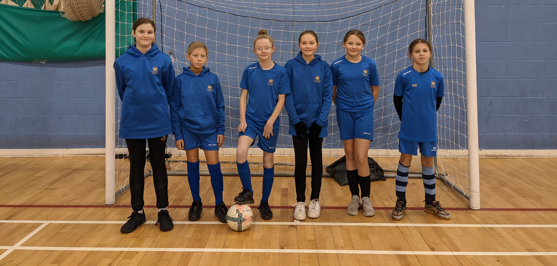

Student of the Term

Each PE teacher nominated a student for Autumn student of the term. Congratulations to these students.

Year 7 Boys – McKenzie Pattison.
Year 7 Girls – Maisy Timms.
Year 8 Boys – Luca Howard.
Year 8 Girls – Olivia Bowskill.
Year 9 Boys – James Agnew.
Year 9 Girls – Scarlett Blenkinsopp.
Year 10 Boys – Shea Maddison.
Year 10 Girls – Miley Dobinson.
Year 11 Boys - Bailey Simpson.
Year 11 Girls - Millie Sanderson.
Year 12 - Zac Seymour
Year 13 - Katie Rutherford

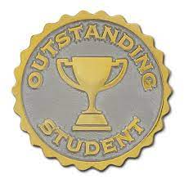


Football Festival

Year 7/8 School Games Football Festival took place on the 29th September. Teams played a range of fixtures with mixed results ending in the boy’s team finishing 2nd and the girls team finishing 3rd. Well done to all competitors.
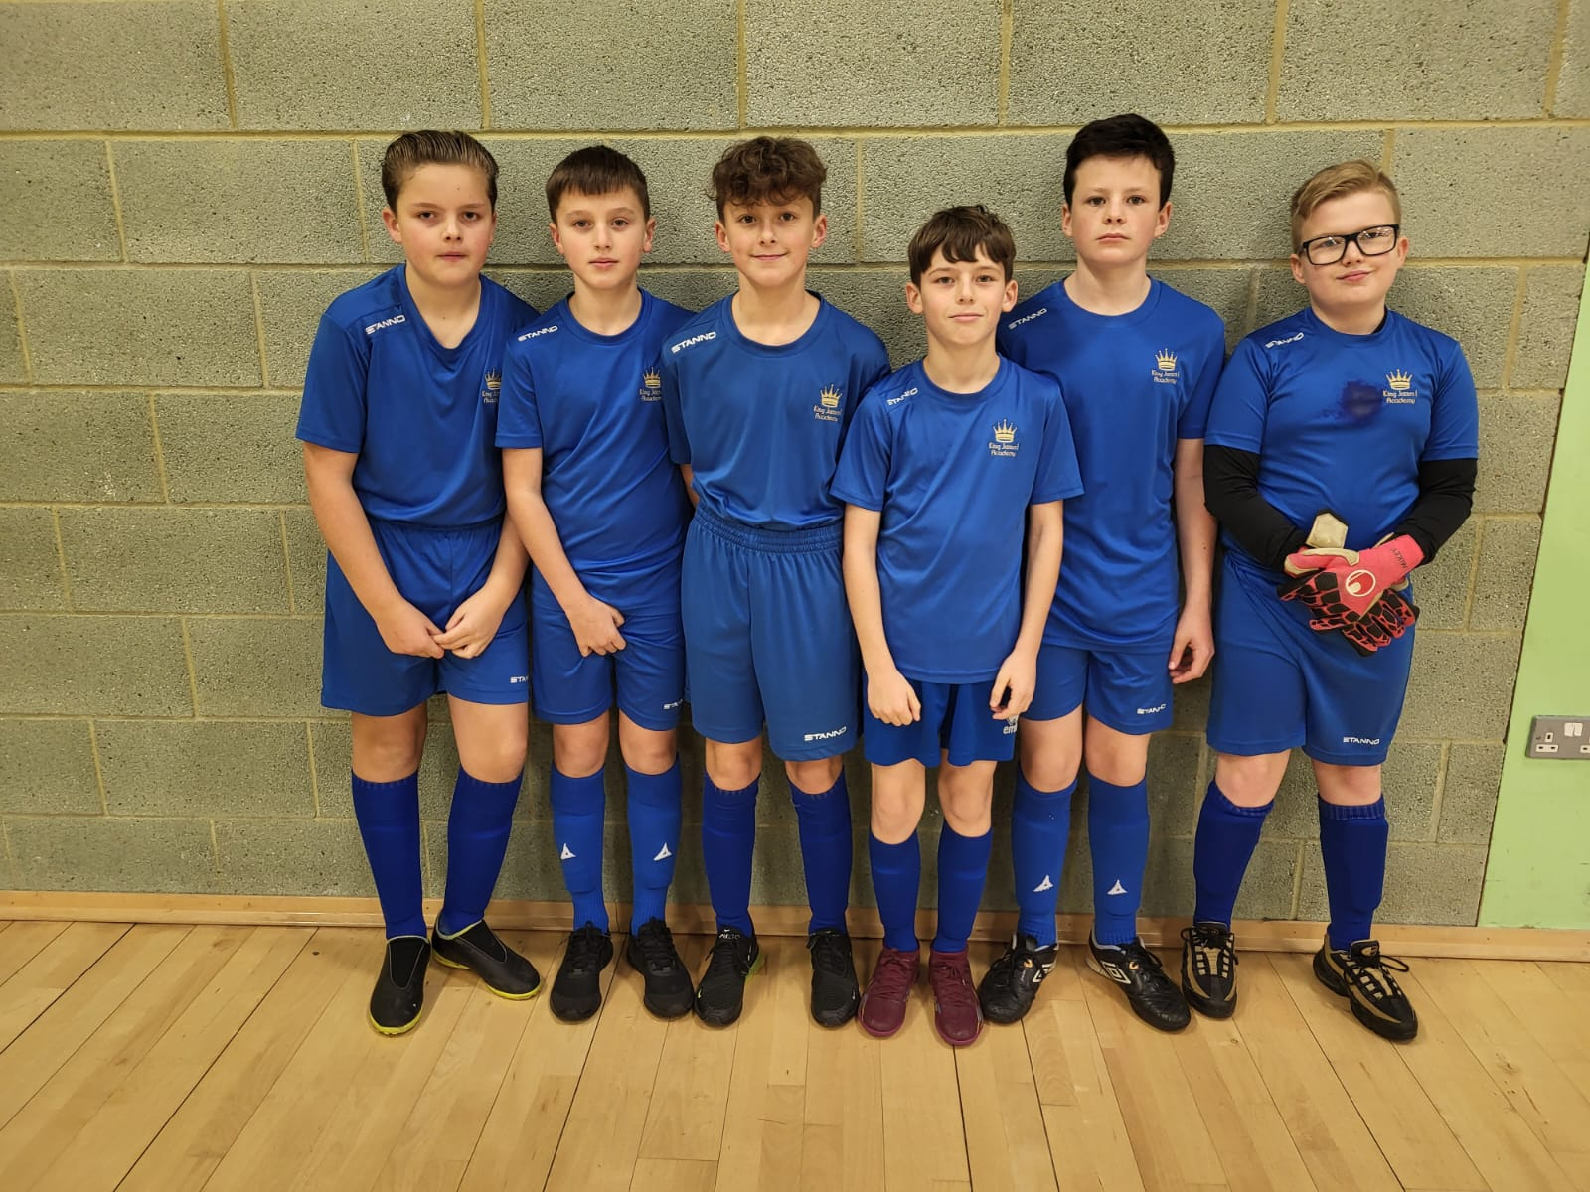

KS3 Curriculum (Jan-Mar)

GIRLS – Trampolining, Badminton, Dance and Tag Rugby.
BOYS – Trampolining, Badminton and Fitness.

Cross – Country Championships

The district cross country championships took place on the 19th October at Barnard Castle. Top 16 finishers would earn their place in the county championships which will be held in January. King James had 7 students qualify; year 7 boys Kaiden Hallimond, Kaine Butler and McKenzie Pattison. Year 7 girls Kianna Walker and Kaitlyn Rutherford and Junior Boys Zac Moffatt and Adam Plews. Well done to these students and all competitors who represented the academy.

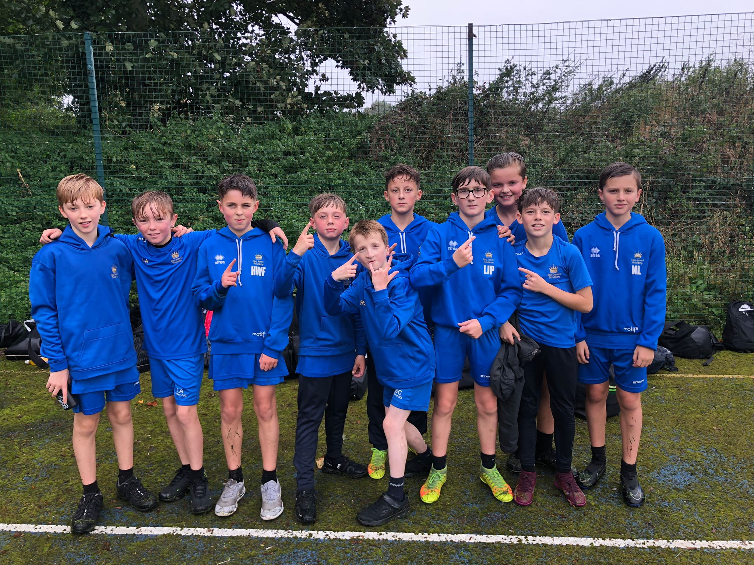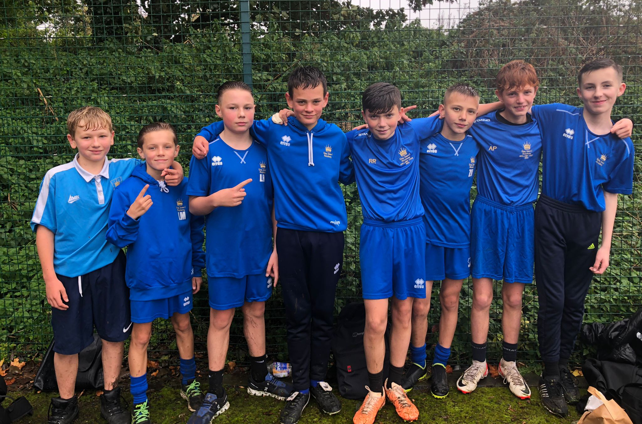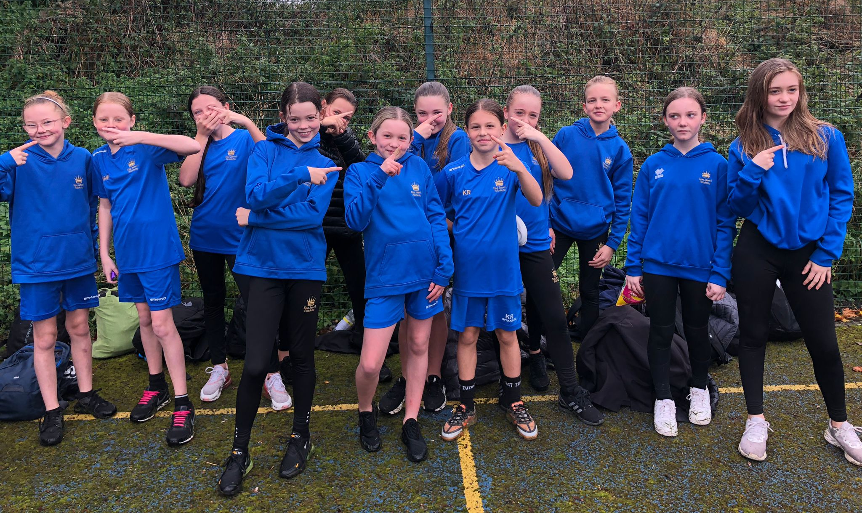

England Talent

Leyla Vickers in year 9 is now officially on the England talent pathway after she attended the initial England camp in November. We have just had confirmation that Layla is now officially on the England talent pathway for at least the whole of 2024.
She has been invited to two further camps on Friday 23rd January and Friday 2nd February, England have an under 15 squad which she can be considered for this year… What a fantastic achievement!!


Yr8 Badminton

Year 8 students played in the school games Badminton festival held at King James 1 Academy on 29th September. Having played numerous matches and demonstrating solid skills and techniques they finished third overall.

